10.24:

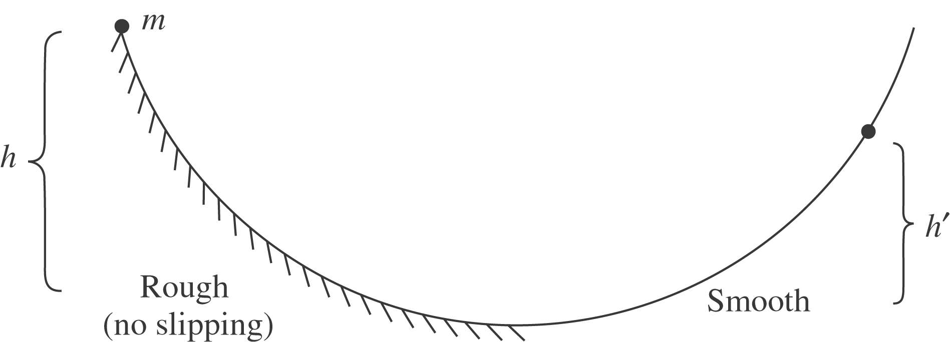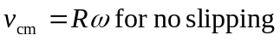

a) Get v at bottom:
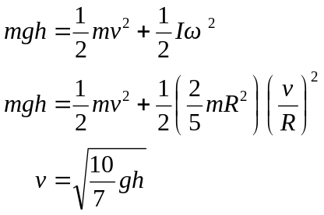

Now use energy conservation. Rotational KE does not change

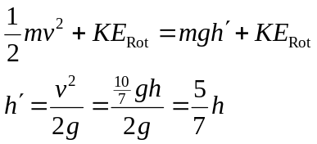

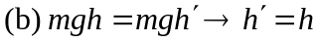 With friction on both halves, all the PE gets converted back to PE. With one smooth side, some of the PE remains as rotational KE.

